SELF SERVICE RESET Verses ADMIN REQUESTED RESET
When you try a manual reset of your E2 account. This is what is sent to the DIRAUX shared inbox. Note, we don’t know who David is and by the time we tried to look up who’s supplier vendor number this username belongs to, the 10 minute link will have long expired.
We need to know before you submit a self-reset as we are not monitoring the shared inbox 24/7. These notices can stack up in the inbox until the next notice below is received.
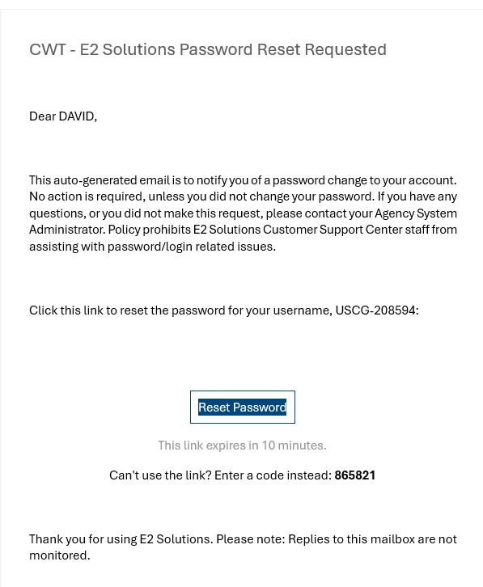

24 HOUR LOCK OUT FROM SELF-SERVICE PASSWORD RESET
If you continue to try to self-reset your account without getting a link, then this will be the notice we get from the system. Note again, we don’t know who Michael is and there is no supplier vendor number associated with this message. The only way for us to now reset you before the 24 hour period, is for you to send us an email to the shared inbox to ask for a reset of your account.

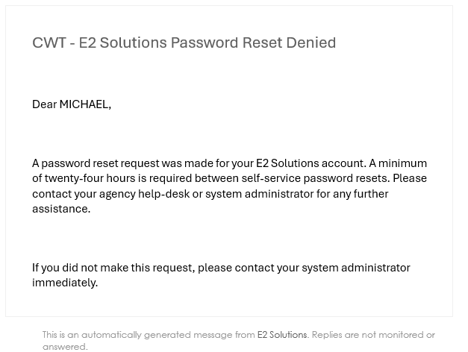

LOCKED E2 ACCOUNTS
The same goes for when you are locked out of the system. This is what we get in the shared inbox. We don’t know who Robert is and the only way we will know whose account need to be unlocked is for you the member to send an email to the shared inbox to tell us that that you need to be unlocked.

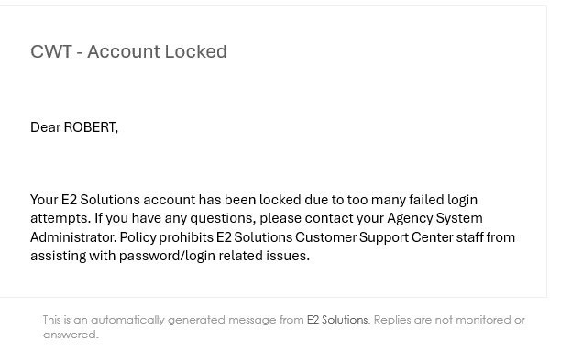

Once you’ve contacted the shared inbox and we’ve successfully unlock your account you can then go into the system and try to sign in again. If you can’t recall your password, the best option is to request a reset. Once an admin reset is done to your account, the below is the email we get in our shared inbox. We will forward this email to you and you will be able to get into E2 again. You have 24 hours now instead of 10 mins to use this link.



