CREATE A TICKET

Simple hit the Create New Ticket at top of screen to the left of your name:
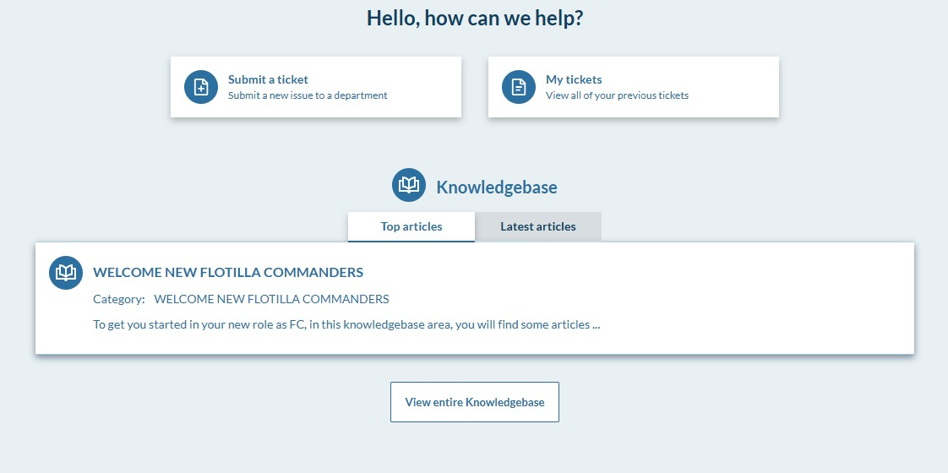
Select the ticket category you want to create:
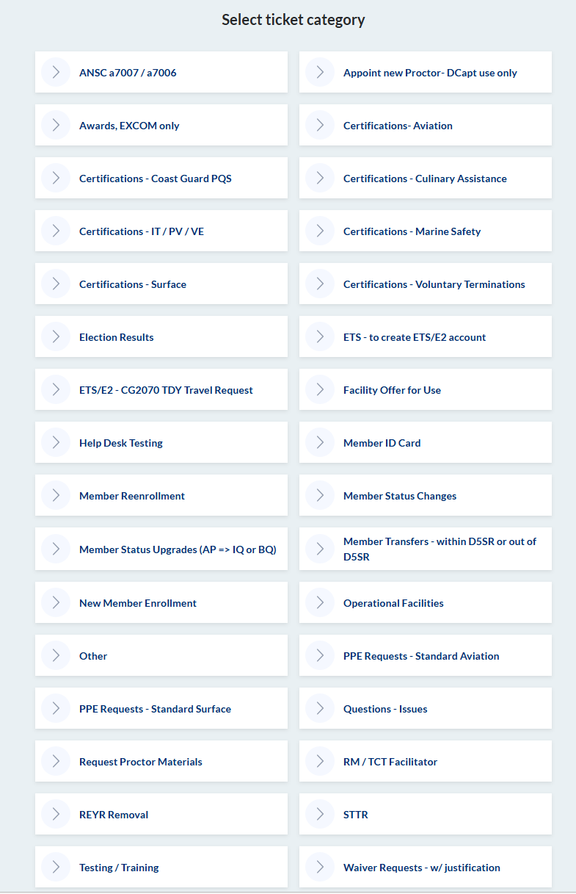
If none of the categories fit for what you’re trying to accomplish, select “other” and give the entry a title that fits your action.
When filling in the ticket, if you desire anyone that is also in HESK to be included on the notification of this ticket, select them as a follower. You can add multiple followers to a ticket.
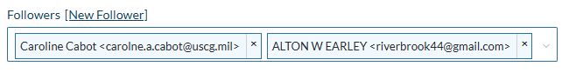
Priority - is optional. A critical priority may get attention, but that might not indicate how fast the action is processed. Remember, our volunteers aren’t here on a daily basis and actions assigned to them will be carried out only when they are in the office or working remotely.
Status – is new when first entered. DIRAUX will control the status of all actions.
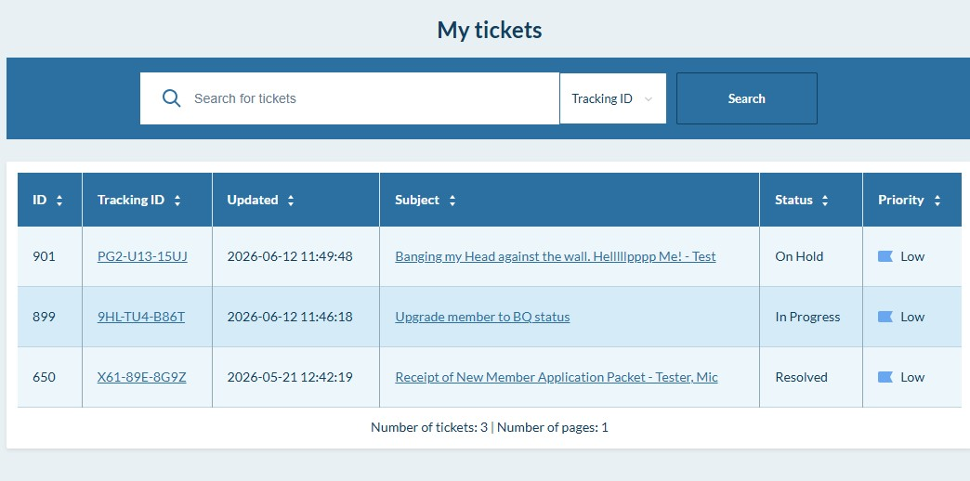

If the status says “waiting for reply” then DIRAUX is waiting for you to come back to us with an answer. Read the notes on the status of actions as it may require you to perform some needed action for the ticket to move forward.
If the status says “In progress” then it means someone is working on it.
If the status says “New” but it’s been assigned to someone, it just means that the action has been worked on by the person it’s been assigned to yet.
If the status says “New” and it hasn’t been assigned yet, then it’ll need to be assigned before it will get worked on.
If the status says “Resolved” the action has been either completed or returned without action to be resubmitted when the action has all the documentation need. Always read the reply of a resolved ticket to see if the DIRAUX office has given you instructions on what needs to be done or information on what has not been done.
If the status says “waiting for reply” please reply on the same ticket and don’t create another ticket.
If the status says “Replied” that means either your replied to DIRAUX and we gotten to read the reply yet.
If the status says “On Hold” that means a ticket has been placed on indefinite hold until the customer returns something to the DIRAUX to allow us to continue processing the action or DIRAUX has received an answer from some other organization such as higher HQ (BSX) to allow us to reserve the action or requires action to be returned without resolution.
If you look in your ticket queue and determine that you have submitted duplicate tickets, delete the ticket. If you don’t DIRAUX will “Resolve” the ticket with a note that it was a duplicate.
When you reply to the ticket, the shared inbox gets notification as well as the staff member the ticket is assigned to.
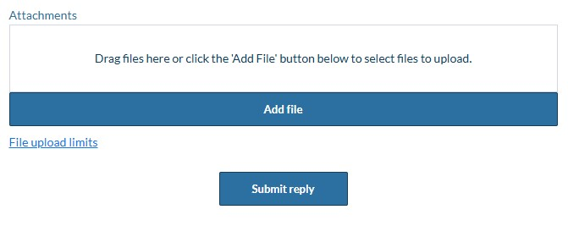
If you’re asked to attach a document or to reattach a document, go up to the edit button on the top of the ticket and attach the file.

Follow the instructions about the upload and note the limits and extension of the files that can be uploaded
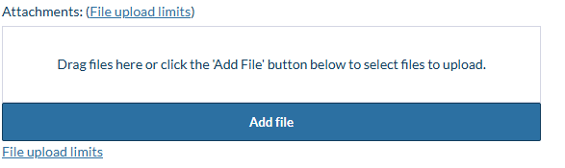
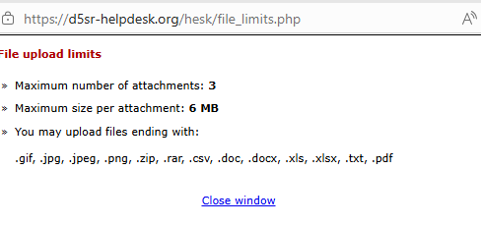
Click the Save Changes at the bottom when all your updates have been made so that your new attachment is saved in the ticket.


